

**AIRTEL EXAMINATION BOARD**

**S.4 END OF TERM 1 ITEM ASSESSMENT PRACTICAL**

**DURATION: 2HRS**

**NAME** ................................................................................................. **STREAM……**

**SIGNATURE……………………………………………………………………………**

**………..**

**Question one**

The armoury unit of one armed forces in Uganda uses amorphous sulphur to manufacture gunpowder. This sulphur is cheaply obtained from a reaction of sodium thiosulphate solution and hydrochloric acid and these are available in the unit stores. However, the management of the unit found out that concentration could be having an effect on the rate of formation of sulphur from the above raw materials, hence a need to minimise their consumption.

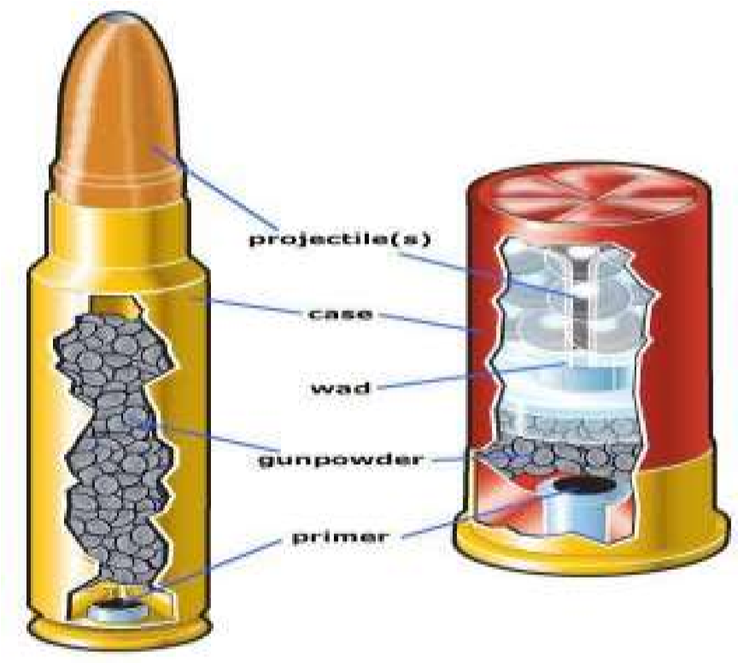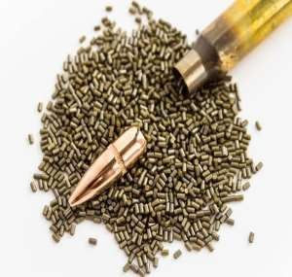

Equation for the reaction

**Na2S2O3 (aq) + 2HCl (aq)** **2NaCl(aq) + S(s) + SO2 (g) +H2O (l)**

**Task;**

(a) As a chemistry student, plan and design an investigation in order to guide armoury unit team to verify their observation.

…………………………………………………………………………………………… …………………………………………

…………………………………………………………………………………………… …………………………………………

…………………………………………………………………………………………… …………………………………………

…………………………………………………………………………………………… …………………………………………

…………………………………………………………………………………………… …………………………………………

…………………………………………………………………………………………… ………………………………………..

…………………………………………………………………………………………… …………………………………………

…………………………………………………………………………………………… …………………………………………

…………………………………………………………………………………………… …………………………………………

…………………………………………………………………………………………… …………………………………………

…………………………………………………………………………………………… …………………………………………

…………………………………………………………………………………………… ………………………………………..

…………………………………………………………………………………………… …………………………………………

…………………………………………………………………………………………… …………………………………………

…………………………………………………………………………………………… …………………………………………

…………………………………………………………………………………………… …………………………………………

…………………………………………………………………………………………… …………………………………………

…………………………………………………………………………………………… ………………………………………..

…………………………………………………………………………………………… …………………………………………

…………………………………………………………………………………………… …………………………………………

…………………………………………………………………………………………… …………………………………………

…………………………………………………………………………………………… …………………………………………

…………………………………………………………………………………………… …………………………………………

…………………………………………………………………………………………… ………………………………………..

…………………………………………………………………………………………… …………………………………………

…………………………………………………………………………………………… …………………………………………

…………………………………………………………………………………………… …………………………………………

……………………………………………………………………………………………

…………………………………………

1. Present your data and analyse it to guide the armoury team.

1. From your data interpretation and analysis above, make a conclusion that can guide the armory team on effect of concentration on rate of reaction between sodium thiosulphate and the acid.

…………………………………………………………………………………………… …………………………………………

…………………………………………………………………………………………… ………………………………………..

…………………………………………………………………………………………… ………………………………………… ……………………………………………………………………………………………

…………………………………………

**END.**